Number of studies Identified through data base searching in different algorithms (n=)

Number of studies Identified through other sources (n=)

***Identification***

***Screening***

***Inclusion***

***Eligibility***

Articles screened on the basis of title, abstract, key words, tables and figures (n=)

Number of articles after removal of the duplicates (n=)

Articles screened on the basis of title, abstract, key words, tables and figures (n=)

Articles excluded which not include PFCs exposure related thyroid hormones (n=)

Articles excluded which didn’t include sufficient information about thyroid outcomes (n=)

Review of full articles and applied inclusion criteria

(n=)

Articles included to explain the association between human PFCs exposure and thyroid dysfunction (n=)

**Fig. S1.** Adapted from the PRISMA (Preferred Reporting Items for Systematic Reviews and Meta-analysis) method.

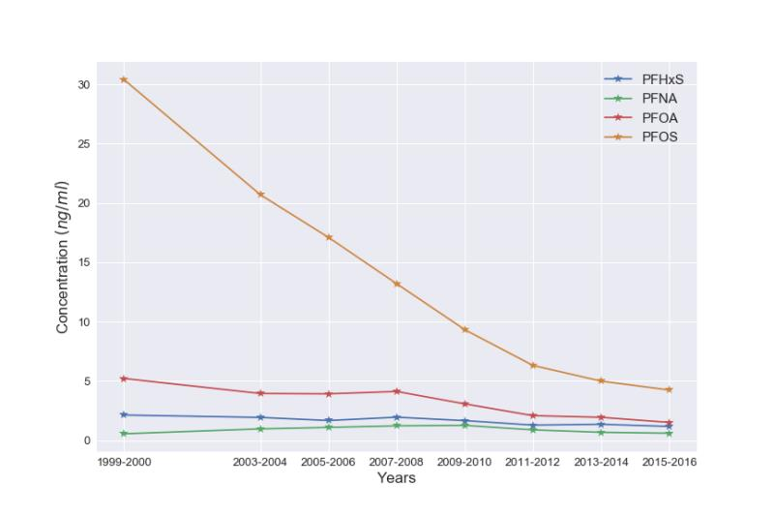

**Fig. S2.** Blood levels of the most common PFCs in U.S. general population from 1999-2016

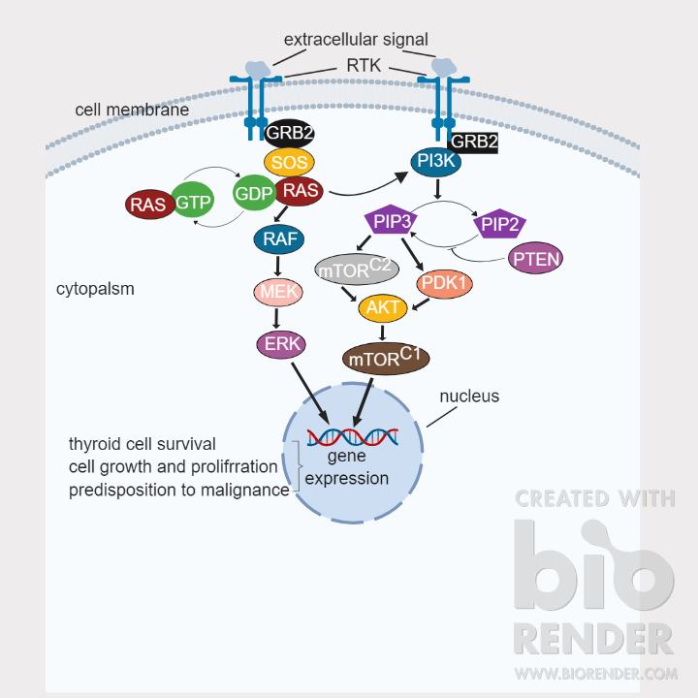

**Fig x**. **Thyroid cancer pathways.** The diagram shows key signaling pathways involved in thyroid cancer. The MAPK pathway is activated by mutation in most thyroid cancers while the PI3K pathway is activated in thyroid carcinomas with increased malignance. RTKs are firstly activated in response to binding of growth factors, allowing recruitment of adaptor and GEF proteins that promote GDP to GTP exchange on RAS proteins, eliciting their activation.